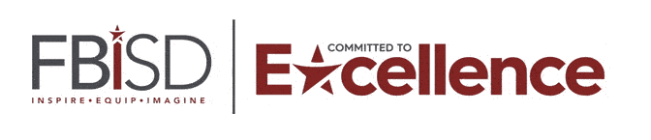

James Reese CTC  
Fall Semester Exam Schedule

*2024 – 2025*

|  |  |
| --- | --- |
| **Friday, December 13, 2024** | |
| 7:15-9:36 a.m. | 1st Period **REVIEW/EXAM** |
| **Lunch Traditional Campus: 10:25-10:55** | |
| 11:00-1:20 p.m. | 4th Period **Review/EXAM**  Block Campus Lunch/Study Hall |
| 1:25-2:09 p.m. | 7th Period |
| **Monday, December 16, 2024** | |
| 7:15-9:36 a.m. | 2nd Period **REVIEW/EXAM** |
| **Lunch Traditional Campus: 10:25-10:55** | |
| 11:00-11:45 a.m. | 4th Period/Block Campus Lunch |
| 11:50-2:09 p.m. | 5th Period **REVIEW/EXAM** |
| **Tuesday, December 17, 2024** | |
| 7:15-9:36 a.m. | 3rd Period **REVIEW/EXAM** |
| **Lunch Traditional Campus: 10:25-10:55** | |
| 11:00-11:45 a.m. | 4th Period/Block Campus Lunch |
| 11:50-2:09 p.m. | 6th Period **Review/EXAM** |
| **Wednesday, December 18, 2024** | |
| AM Students will remain at their home campus | |
| **Lunch Traditional Campus: 10:25-10:55** | |
| 11:00-11:45 a.m. | 4th Period/Block Campus Lunch |
| 11:50-2:09 p.m. | 7th Period **Review/EXAM** |
| **Thursday & Friday, December 19 & 20, 2024** | |
| No Students at James Reese Career & Technical Center  Reese Teachers will be sent to designated high schools to support Reese students. | |
| ***11:40 a.m. – Early Release***  *Transportation will run the high school bus routes at the early release times listed.*  *On early release days, middle schools and high schools provide all students an opportunity to receive lunch.* | |